Trip Leader Bios – Scroll down to hear from both Sigrid and Anna Kite

Shalom everyone! My name is Sigrid Kite and I have been a longtime community member of the JCC in Denver and Boulder. I grew up going to Ranch Camp as a camper, and came back in the summers of 2014 and 2015 to work as the Teva Wildlife Specialist and the Rosh Specialist. Last summer, I decided to go a little younger and worked at the JCC ECE in Denver, and I’ll continue to work there this summer after our trip! I have also been subbing and working part-time at the JCC ECE in Boulder this past school year.
I recently graduated from CU at Boulder with a degree in Integrated Physiology and a certificate in Public Health. For the past two years I have worked as a research assistant in a psychopathology lab that studies post-partum depression in first time mothers. This experience has inspired me greatly and I plan to get my masters in Maternal and Child Public Health in the future. This past semester I took a Global Health class where we were required to choose a country and study their health system. I decided to study the Dominican Republic in preparation for our trip, so if anyone would like to learn more about health in the Dominican Republic, I would be happy to pass along my final paper!
When I am not studying, I love to run, practice yoga, go on hikes, read, cook with my roommates, and watch Netflix documentaries. I am so thrilled to be leading the trip to the Dominican Republic. I am excited to reconnect with long-time campers, meet new faces, and together grow as we go on an incredible journey. I am counting down the days until I see everyone, but in the meantime, if anyone has any questions or concerns, please feel free to reach out to me!
Sigrid

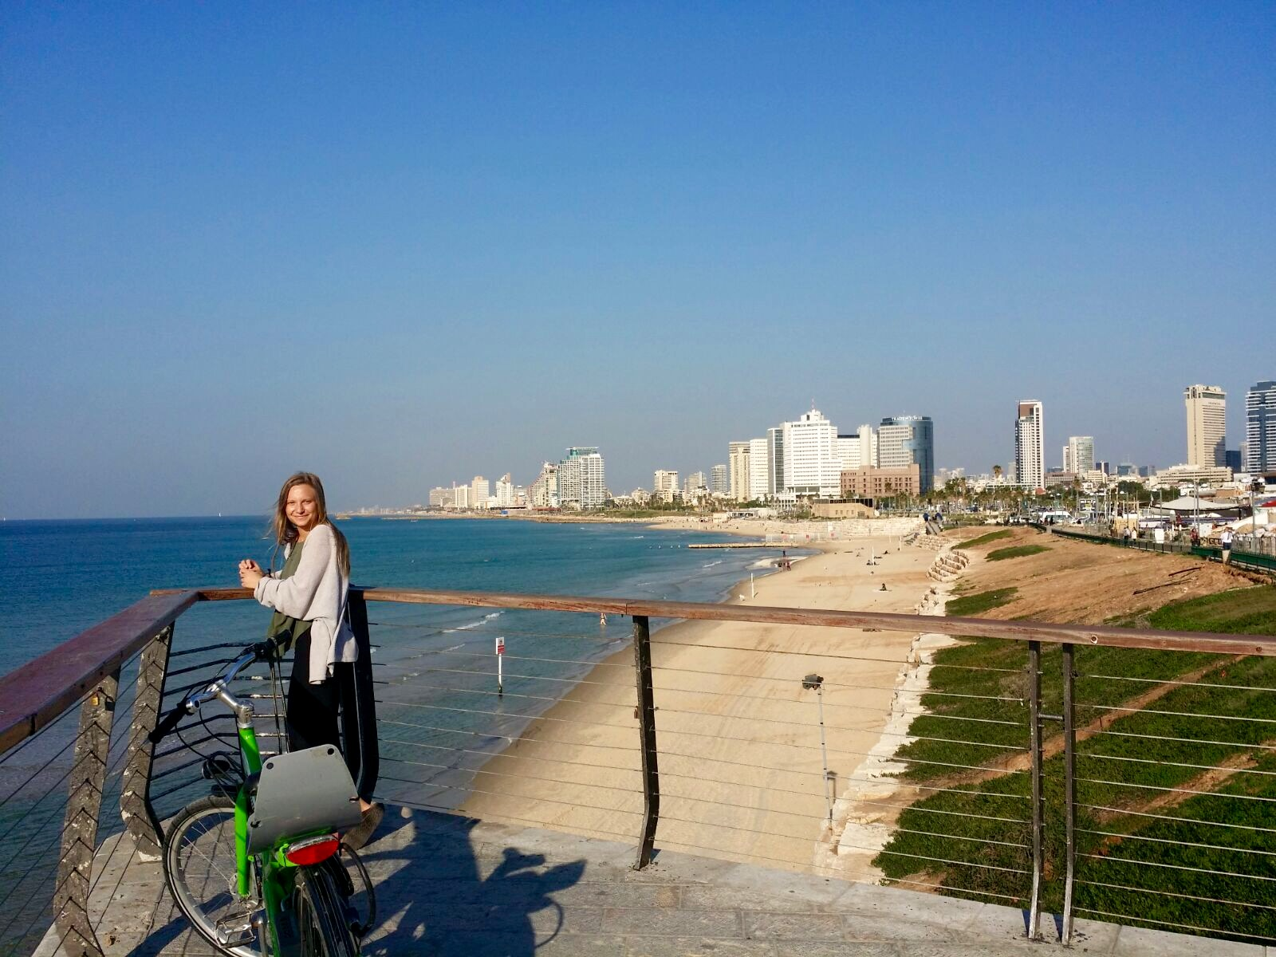
Picture taken in Tel Aviv, Israel, January 2016
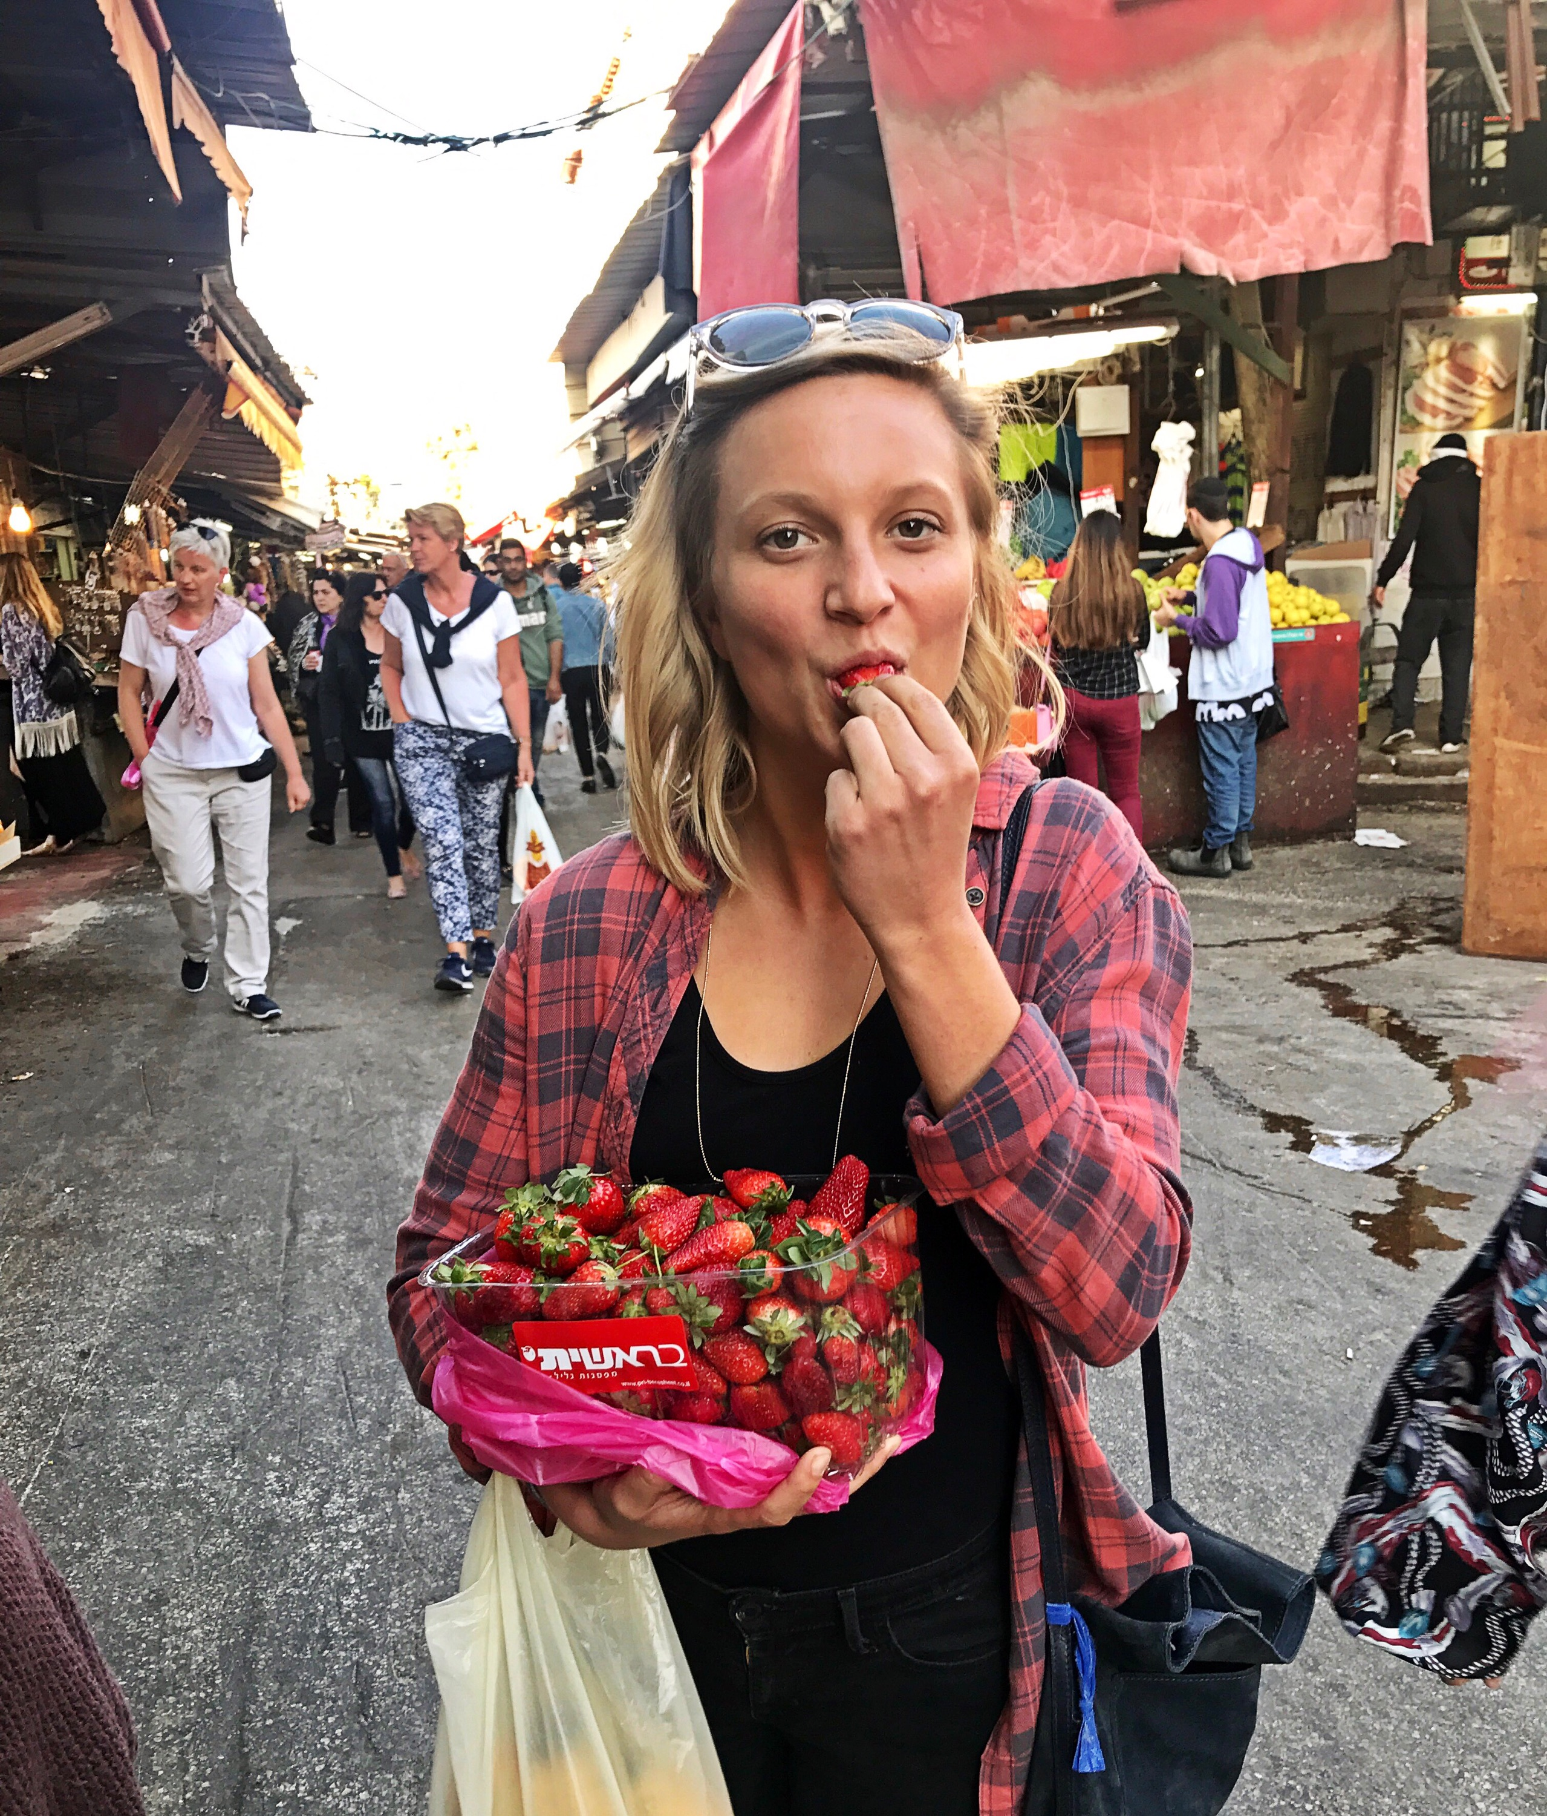

Hello, Hola, Shalom!

I am overjoyed to have the opportunity to accompany you on this adventure! I grew up in Denver and have been a part of the JCC for years and years. As a camper at Ranch Camp I was pretty exclusively a horse girl, and in most recent years have served as the Rosh Specialists and Assistant Director.

My background and schooling is in education, with an emphasis in environmental studies and sustainable agriculture. I had the pleasure to study in the beautiful Northeast at the University of Vermont. Now, I’m a Pre-K teacher and garden-to-table coordinator at the American International School in Israel. I’m living a dream. I spend my weekdays with creative and spunky young children, and my weekends driving and biking around this beautiful and inspiring country.

I’m so looking forward to the connections we’ll make on this journey together. See you very soon!
-Anna Kite

