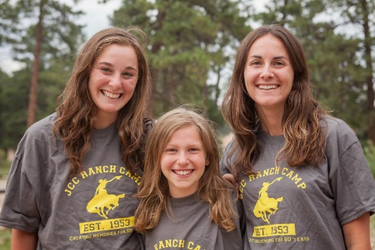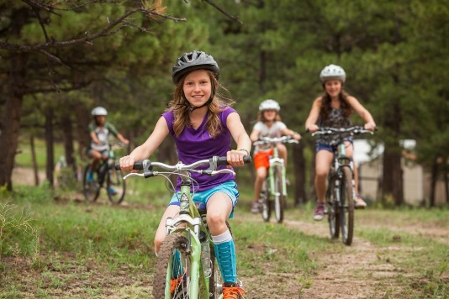



Ranch Camp 2014

Parent Handbook

**Dear Ranch Camp Families,**

Shalom, and welcome to the JCC Ranch Camp. We are happy you have chosen to join us for your camping experience this summer; an experience full of exciting and enriching camp programming under the supervision of mature, competent, and caring staff.

We believe that the impact of our Jewish camping experience is both invaluable and immeasurable. Each summer we strive to create an atmosphere where every child is constantly nurtured. We are committed to safety in all areas, supervision of each camper twenty-four hours a day, and programming that is fun, challenging, and growth oriented.

This Parent Manual contains information about your child's summer and is designed to better acquaint you with the Ranch Camp, even if you and your children are "veterans." We recommend reading this manual with your children who will be attending camp, because we find that when campers are involved with preparing for camp, such as talking about programs or packing for camp, they feel invested in the experience and generally adjust with greater ease to camp life. Any questions or concerns that are raised while reading this manual should be addressed immediately. We are more than happy to answer any questions.

We look forward to seeing many returning campers and welcoming campers who are with

us for the first time!

B’Shalom,

Miriam & Gilad Shwartz

JCC Ranch Camp, Co-Director

**Camp Directors**

**Miriam Shwartz- Director Gilad Shwartz- Director Gina McReynolds – Assistant Director**

Email: [miriams@jccdenver.org](mailto:miriams@jccdenver.org) Email: [gilads@jccdenver.org](mailto:gilads@jccdenver.org) Email: gmcreynolds@jccdenver.org

Winter Office : 303-316-6384 Winter Office: 303-316-6321 Winter Office: 303-316-6384

**Camp Summer Office: 303-648-3800**

**Directions to Ranch Camp** * Ranch Camp can be correctly located using GoogleMaps. We do not suggest any other GPS tool or site.*

**Ranch Camp 2014 Dates**

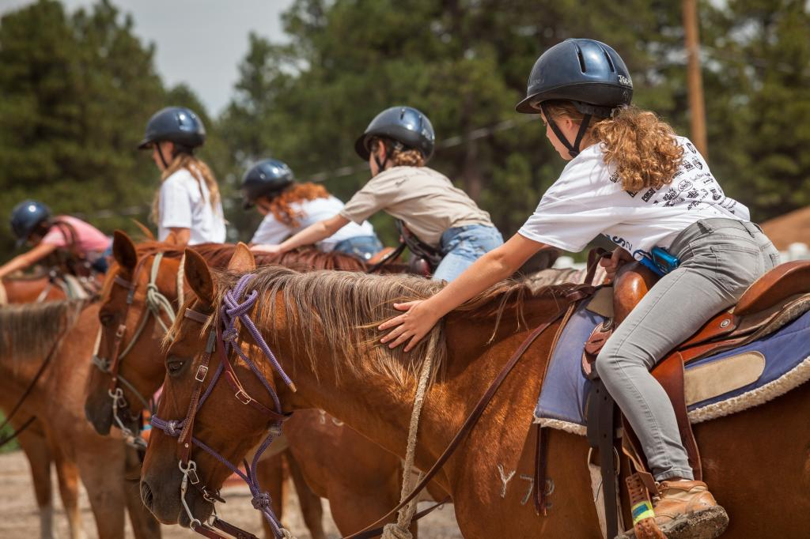

**Open House- Sunday, June 8th, 2014**

JCC Ranch Camp, 21441 N Elbert Rd, Elbert CO 80106

11 a.m.-3:00p.m.

**Session I Session II**

Mini Camp: Sunday, June 15th –Sunday, June 22nd Mini Camp: Wednesday, July 2nd - Sunday, July 13th

Full Session: Sunday, June 15th –Sunday, June 29th Full Session: Wednesday, July 2nd – July 20th

**Session III Teen Village**

Mini Camp: Wednesday, July 23rd – Sunday, August 3rd Sunday, July 13th – Sunday, August 10th

Full Session: Wednesday, July 23rd – Sunday, August 10th

**Family Camp**

Friday, August 15th – Sunday, August 17th

**From Colorado Springs**

* Take I-25 N to US-24
* Take US-24 east past Falcon
* Go approx. 3 miles, look for a sign on the left indicating Elbert Rd.
* Turn left onto Elbert Rd and continue for approx. 13 miles.
* Camp will be on your left.
* (If you’ve passed the Boy Scout camp and/or and town of Elbert, you’ve gone to far.)

**From Denver on Parker Road**

* Take Parker Rd (Hwy 83) to Franktown, Co.
* Turn left (east) at the stoplight in Franktown onto HWY 86.
* Take HWY 86 thru Elizabeth.
* Turn right at the stoplight for CR17. (Last light in Elizabeth)
* Continue on CR17/21 until you reach a stop sign.
* Turn left at the stop sign onto CR 102 .(Do NOT take dirt roads! Stay on paved road.)
* Turn right at stop sign onto Elbert Rd.
* Continue past the town of Elbert for approx.. 3 miles.
* Camp will be on your right after the Boy Scout Camp.

**From I-25**

* Take I25 S to Founders Pkwy (exit for the Outlets at Castle Rock)
* Exit highway and turn left onto HWY 86 (Founders Pkwy)
* Cont. on HWY 86 turning left at the light for HWY 86 (5th Ave).
* Take HWY 86 thru Franktown and Elizabeth.
* Turn right at the stoplight for CR17 (last light in Elizabeth).
* Continue on CR17/21 until you reach a stop sign.
* Turn left at the stop sign onto CR 102.(Do NOT take dirt roads! Stay on paved road.)
* Turn right at stop sign onto Elbert Rd.
* Continue past the town of Elbert for approx.. 3 miles.
* Camp will be on your right after the Boy Scout Camp.

**About the Ranch Camp**

**Mission Statement**

The mission of the JCC Ranch Camp is to provide a resident camping experience for youth that enables campers, staff and families to strengthen their Jewish identity, become more caring and responsible members of society, and connect with the natural world through challenging and fun activities, knowledge and skills are learned to help build friendships, community and support personal growth.

In fulfilling its mission, the JCC Ranch Camp provides:

• Innovative learning opportunities for children and staff members in a “Western Judaic” environment that challenges growth in mind, body, and spirit.

• A safe place for children to be cared for by qualified professionals, with a commitment to safety, supervision, customer service and Judaic programming.

• Opportunities for children and adults to experience a nurturing community based on Judaic values

**Ranch Camp Middot**

At Ranch Camp we look try to practice seamless Judaism by weaving Jewish values, which are universal values, into the activities and experiences of camp.

**Our theme for Summer 2014 is *Meshaneh Habriot: Diversity in the World***

1. **Art** – *Modeh/Modah Ani: Appreciation* – We are aware of and appreciate one another and the wonders of the world around us.
2. **Ropes Course** – *Im Lo Achshav, Eimatai?: If not now, when?* – Thoughtful risk taking helps us to grow. We aim for our person best.
3. **Rikud (Dance)** – *Shmirat Haguf: Taking Care of and Respecting our Bodies* – We value our health and well-being and act accordingly. We make choices that reflect that we respect ourselves and our bodies.
4. **Mountain Biking** – *Masa: Journeys* – Our journeys in life are both challenges and opportunities. The journey itself and our approach is as important as achieving our goals.
5. **Drama** – *Otzmat Milim: The Power of Words* – Our words are powerful and make a difference in our community. We are careful to use our words in constructive and helpful ways.
6. **Archery** – *Acharayut: Responsibility* – We are mindful of the well-being of those around us. We are responsible for ourselves, for one another and for the welfare of our community.
7. **Corral** – *Kavod Habriot: Respecting all Creation* – We treat all of the life around us with deep respect and compassion. We are grateful for the opportunity to interact with both people and animals at camp.
8. **Music** – *Hachnassat Orchim: Welcoming Everyone* – We value the contribution that everyone can make and understand that the strength of the group is dependent on each individual.
9. **Sports** – *Gesher Tsar M’od: The World is a Narrow Bridge; Do Not Fear*
10. **Pool** *– Pikuach Nefesh: To Save a Life* – The preservation of human life is the highest priority. We are committed to developing the skills and knowledge that support us in maintaining our health and the ability to help others.
11. **Teva** – *Shomrei Haadamah: Protecting the Planet* – We are aware that the welfare of our planet depends on us. We have a responsibility to protect our planet and repair the world (tikkun olam).
12. **Israel and Judaics** – *Kehillah: Community* – We are all part of the camp community. We will cultivate a camp community that is inclusive, welcoming and supportive.
13. **Tie Dye** – *Al Tistakel Bakankan Ela Bema Sheyesh Bo: Don’t Jude a Book by its Cover*

**Parents’ Role at Camp**

In order to make this camping season as successful as we would all like it to be, we are asking parents to join us in a partnership. We need you, our partners, to take responsibility to do the following:

• Include your child in the process of preparing for camp.

• Fill out the forms completely and return them on time (this a critical component in state licensure, and in an emergency situation)

• Communicate with us about potential concerns, your child’s fears, and successful ways of helping your child work through his or her fears.

• Use positive language to help your child to be excited about camp.

• Send your child mail. (Sending the first letter several days before camp begins ensures that camper(s) will receive mail in the first few days)

• Read, understand, and support our policies.

• Give us feedback about how we met you/your child’s needs.

**Visitation**

There are NO visiting days during camp sessions. This policy is in place because parent

visitations can not only prove incredibly disruptive to the “camper experience” but also

tend to create or intensify homesickness. If you wish to visit Ranch Camp, we welcome

you to do so during a time that your child is not attending camp. To schedule a tour of camp,

contact us at 303-316-6384.

**Ranch Camp Transportation Procedures**

Change in plans? Problems or concerns? Please contact us with any last minute travel changes or queries first at the. Ranch Camp Office at 303-648-3800 or, if you unable to reach us there, at 303-408-3841 (Camp Emergency Number).

**First Day of Camp**

**DROP-OFF IN DENVER (Bus transportation)**

Location: Denver Jewish Day School, 2450 S. Wabash Street, Denver, CO 80231

**> Campers with medications and/or vitamins should check-in at 10:00 am**

**> Campers without medications and/or vitamins should check-in at 10:30 am**

No staff will be available to care for campers until the designated time. As you pull into the parking lot, please park your car and then drop off your luggage. Check-in will take place in designated areas adjacent to the parking lot, next to the building. Meet with our clinic staff to check-in medications. Please remain with your camper(s) until you finish the check-in process and they join their madrichim (counselors) and bunkmates.

**DROP-OFF AT THE RANCH CAMP** (only for campers who live in Parker or south of camp)

**Drop-off will take place between 12-12:30 pm at the Ranch Camp.** Staff will not be available to care for your campers before that time. Please check-in your campers at the camp office. You will drop off medications with the staff in the office at this time because the camp doctor/nurse will be in Denver. Please call and talk to the doctor/nurse in advance of your camper’s arrival if you have any special medical concerns. Please say goodbyes once campers are checked-in. Transitions are easiest on the campers when goodbyes are short and clearly defined. We appreciate your cooperation in this matter.

**ARRIVALS INTO DENVER INTERNATIONAL AIRPORT (DIA)**

**On the first day of each session, flights should arrive between 10 AM and 12 PM.**

If you are unable to schedule a flight within these times, please email or call our office to discuss alternatives. Please keep us updated on any changes or flight delays, especially on the day of arrival. A uniformed staff member will greet your campers at the gate, and will then take your campers to the designated Ranch Camp meeting place. Campers are not allowed to leave the group unless accompanied by a staff member.

**Last Day of Camp**

**PICK-UP IN DENVER (Bus Transportation)**

Location: Denver Jewish Day School, 2450 S. Wabash Street, Denver, CO 80231

**For all sessions, last day pick-up is at 11:00 am.** Please make certain to sign out your

camper with their madrich(a) (counselor) BEFORE leaving. Medications and any other miscellaneous items will be available for pick-up. Their luggage will unloaded and waiting for you to claim.

**PICK-UP AT THE RANCH CAMP**

**For all sessions, last day pick-up is at 9:30 am.** Please park your car and proceed to the office to sign out your camper and pick up their luggage.

**DEPARTURES FROM DENVER INTERNATIONAL AIRPORT (DIA)**

**On the last day of all sessions, flights should depart between 11 AM and 2 PM**. If you are

unable to schedule a flight within these times, please email or call our office to discuss alternatives. Please make certain that you have paid for the unaccompanied minor fee (if applicable) and baggage fees required by the airlines, for each child. A uniformed staff member will take your campers to their gate, will check your campers in with airline personnel, and will wait at the gate until the flight has taken off.

**INTERSESSION OPTION (OUT-OF-TOWN FAMILIES)**

We have a 2-day intersession between Sessions 1&2 and 2&3. If you are sending a camper from out-of-town and would like to arrange for a Ranch Camp approved host family to care for your child during this time period, please contact our office for assistance in making arrangements well in advance.

**INTERSESSION OPTION (LOCAL FAMILIES)**

We have a 2-day intersession between Sessions 1 & 2 and 2 & 3. In the past, local families who wanted to do multiple sessions of Ranch Camp back-to-back were left to find childcare for these in-between days. This year we are working with Camp Shai to offer a day camp experience for these 2 days of intersession at a cost of $140. Please contact our office if you’d like to take advantage of this offer.

.

.

.

**Payment, Cancellations, Scholarships, and Donations**

**Payment Schedule**

Registrations are processed with either payment in full or a payment plan for a $25 fee. All payments must be collected prior to a child attending camp. In order to be fair to campers on the wait list, space will no longer be reserved for registered campers after deadlines if fees are not paid in full. Separate deadlines pertain to scholarship applicants.

**Changes/Cancellations**

Camp expenses are fixed in advance, based upon a definite number of campers for specified times. No rebates or discounts from fees can be made for entering late or leaving early. Changes or cancellations must be made in writing. Payment on your account, minus a $200 administrative fee, will be refunded or credited to your account before May 1, 2014; after this date, payment can only be transferred to other JCC Denver camping programs or held towards 2015 Ranch Camp tuition (must register by 12/31).

**Scholarships**

The JCC Ranch Camp is committed to providing a high-quality camping experience to all who seek it regardless of financial circumstance. Please indicate that you will be applying for scholarship at the time of registration so that we can send you application information. Aid applications are processed online by FACTS Grant & Aid Assessment; the submission deadline is April 15, 2014.

**Donations**

For those families who wish to make a tax-deductible donation to the JCC Ranch Camp (for camper scholarships or for capital improvements), go to www.jccdenver.org/give. Contributions such as furniture, equipment, office supplies and sporting goods are also needed and welcome. Please call our office if you’d like to make a physical donation.



**Camp Forms**

The forms for camp, found in your camp account online, must be completed and submitted before the start of camp. No camper may come to camp without a completed forms. Many of the forms require parent signatures or physician signatures. Please have your forms turned in by June 1st.

**It is incredibly important that your camper forms be filled out as completely as possible in order for us to best serve your camper this summer at camp.**

Having these forms makes for safe and healthy children at camp and at home. This information will help us get better acquainted with your family and child, and information on your physician form and health history form will assist our staff in caring for any special needs your child may have. Feel free to arrange a meeting with your camp director to discuss specific dietary and health-related restrictions.

**Activities Release Review**

During their stay, campers engage in activities like horseback riding, a high ropes/challenge course, swimming, field trips, rafting, etc. In accordance with state law, and American Camping Association guidelines, we require consent from parents/guardians authorizing campers to participate in these activities. Parents may write on the authorization form that they choose not to allow their child to participate in any of the designated activities and/or their doctor should indicate activity restrictions.

**Acknowledgement of Guidelines and Waivers**

***Please review the following guidelines which are included in your camper forms.***

**JCC Ranch Camp Transportation Statement**

I understand that during the summer season, campers may take excursions beyond the Denver JCC Camps’ properties. If being transported by camp, campers are transported in seat-belted vehicles, or by bus with licensed drivers who meet insurance and Colorado Dept. of Human Services criteria, and are under the supervision of Denver JCC camp staff members, by signing below I am enabling my child to go on such excursions.

Safety rules for vehicle and bus travel- Passengers should remain seated at all times with hands and arms inside the vehicle. Seat belts should be fastened when riding in vehicles. Noise levels should be as to not distract the driver. There should be no throwing of objects or other disruptive behavior. Passengers should enter and leave the vehicle under the direction and supervision of a staff member and/or driver. If the vehicle needs to make an emergency stop, passengers should follow directions of a staff member and/or driver and use the buddy system if leaving the vehicle.

**Media Release**

The JCC Ranch Camp reserves the right to video, photograph, and use audio recordings of campers during their summer sessions. These promotional mediums are used for recruiting and publicity purposes throughout the year.

**"PG " Movie Permission**

As you know, Colorado weather can often sneak up on us when we least expect it. One of the activities that may occur in the event of bad weather (the exception, not the rule!), is to watch a movie. Without your consent, we are only allowed to let the campers view movies that have a General Audience (G) rating. The PG Permission gives us permission to show movies with a PG rating. Movies of a violent or sexual nature will not be shown.

**Horseback Riding Release**

1. I acknowledge that horseback riding, trail rides, or using horses entail known and unanticipated risks which could result in physical, emotional injury, paralysis, death or damage to myself, to property or to third parties. I understand that such risks simply cannot be eliminated without jeopardizing the

essential qualities of the activity

The risks include, among other things: loss of control, collisions; horses, irrespective of their previous behavior and characteristics, may act or react unpredictably based upon instinct, fright, or lack of proper control by rider, such as biting, kicking, bucking, lying down or stumbling; latent or apparent defects or conditions in equipment, animals or property; acts of other participants in this activity, adverse weather conditions; contacts with plants, insects, or animals; my own physical condition or my own acts or omissions, the condition of the remote roads, trails, waterways, or terrain, and accidents connected with their use; first-aid, emergency treatment or other services rendered; consumption of food or drink. Furthermore, JCC RANCH CAMP staff members have difficult jobs to perform. They seek safety, but they are not infallible. They might be unaware of a participant's fitness or abilities. They might misjudge the weather, the elements, or the terrain. They may give inadequate warnings or instructions, and the equipment being used may malfunction.

2. I expressly agree and promise to accept and assume all risks existing in this activity. My participation in this activity is purely voluntary, and I elect to participate in spite of these risks. Furthermore, I agree to exercise all necessary caution and to obey the safety instructions of the staff involved.

3. I hereby voluntarily release, forever discharge, and agree to indemnify and hold harmless JCC RANCH CAMP from any and all claims, demands, or causes of action, which are in a way connected with my participation in this activity or my use of JCC RANCH CAMP's horses, equipment or facilities, including any such claims which allege negligent acts or omissions of JCC RANCH CAMP.

4. Should JCC RANCH CAMP or anyone acting on their behalf, be required to incur attorney's fees and costs to enforce this agreement, I agree to indemnify and hold them harmless for all such fees and costs.

5. I certify that I have adequate insurance to cover any injury or damage I may cause or suffer while participating, or else I agree to bear the costs of such injury or damage myself. I further certify that I have no medical or physical conditions which could interfere with my safety in this activity, or else I am willing to assume and bear the costs of all risks that may be created, directly or indirectly, by any such condition.

6. In the event that I file a lawsuit against JCC RANCH CAMP, I agree to do so solely in the state of Colorado, and I further agree that the substantive law of that state shall apply in that action without

regard to the conflict of law rules of that state. I have been informed of the State equine liability act.

**Property Liability Waiver**

The Ranch Camp is not responsible for lost, stolen, or damaged clothing and personal items, nor does the camp assume liability for loss or damage to any items left at the camp.





**Health and Wellness**

**Preparing for Camp**

**Emergency Contacts**

Please fully fill out the Ranch Camp Emergency Contacts section on the Health History form. In the event of an emergency, all efforts will be made to contact the parents/guardians of the campers. If we are unable to contact the parents/guardians, we will then try to contact the Emergency Contacts which you have provided. Please make sure to include the names, relationships, and phone numbers of people to whom you give permission to pick up your child from camp in the event that you are not available. Someone who is NOT listed on this form will not be able to pick up your child on the last day of camp.

**Copy of Insurance Card**

The Ranch Camp does not provide camper insurance. Each child must have personal health insurance. Camper medical costs incurred during the summer including prescriptions, doctors' visits or hospital bills, will be charged to the parents and their insurance. Insurance information is requested on the Health History form. A photocopy of the insurance card must be on file with us. If you currently have no insurance or don't want to use your insurance for medical issues, you must sign a medical liability release waiver that holds you responsible for all medical charges incurred over the summer. If you need a copy to sign, please call our office.

**Health Examination by a Licensed Physician**

The State of Colorado Human Services Department and the American Camping Association (ACA) require a physical examination within 24 months prior to camp. However, we would like everyone, when possible, to have their exam within at least 6 months of camp. The physical exam must be completed and signed by a physician. The immunization history must be filled out and up-to-date. Note: Tetanus immunizations are good for 10 years, unless there is an incident, in which case a booster is necessary if it's been more than 5 years since your child's last shot.

The JCC Ranch Camp strives to provide a safe and healthy environment for your child. We have a fully equipped health center staffed by a professional health care provider 24 hours a day. A physician is on call 24 hours a day. We use local Urgent Care (non- emergent) services for campers during the summer. Major hospitals are located 35 miles away in Colorado Springs and 50 miles away in Denver. "Flight for Life" staff and emergency vehicles are on call for the camp all summer. Dentists, orthodontists, and other specialists are also on call in case of emergency. Full safety precautions are taken at all times, and staff members are trained in First Aid and CPR.

**Immunization Requirements**

The Ranch Camp prioritizes the health, safety and well-being of children above all else.

To that end, the JCC has decided, as most schools already have, to more strictly enforce the Colorado Department of Public Health and Environment's immunization standards designed to better protect the health and safety of all members of our ECC community**. Ranch Camp will only enroll children who have been administered the MMR and Varicella vaccines OR who can show proof of immunity via a blood test.** Medical professionals advise that immunizations protect our children and staff allowing socialization in an environment that is of the highest standards of health and safety. When our children and staff are healthy and safe, a quality program can take place. We realize this may, for some, not be in sync with your personal beliefs. If the cost of obtaining the required immunizations poses a problem for you, you can learn where to obtain immunizations free or a low cost by calling the Family Health Line at 303-692-2229 or 1-800-688-7777 or the Colorado Helpline at 1-877-467-2911. We appreciate your cooperation with this important policy decision. Prior to the summer we will audit our immunization records. Please make sure your child's record is up to date by providing the required information on our online health form.

**PARENT QUESTIONNAIRE**

Making the camping experience a success requires a partnership between families and the camp.

**Your assistance in providing the camp with detailed information regarding your child is of paramount importance**! This is especially valuable when a child has special needs or there has been a recent disruption in his/her family life, such as moving, separation/divorce, or death.

Please be assured we only have the best interest of your child in mind, but we cannot help if we do not have background information. Discussions with the camp staff will remain confidential.

**Health While at Camp**

Please fill out the Health History completely and accurately. Our camp clinic staff reads through every health history for daily medicines, dosages, times, etc. We may call you to verify accuracy, and sometimes to work with you to adjust your child's normal routine to a camp setting.

**Policies in Regards Parental Communication in the Health Center**

Phone contact with parents/guardians is established in an emergency. Each person’s health and emergency contact forms contain primary contact information and designates alternate contacts if the parents/guardians cannot be reached. This process is initiated by the directors and/or the lead health care provider, but can be delegated to an appropriate staff member. An emergency is defined as any situation in which a camper has to be sent immediately to a clinic or hospital, either by camp vehicle or an emergency services vehicle.

Parents will also be contacted in the event that their child is required to remain in the camp health center for more than a 24-hour period or has to see a doctor at a clinic. An attempt to contact parents/guardians will be made prior to the camper going to the clinic. If the parents/guardians or emergency contacts are not available, calls will be made upon the camper’s return to camp. All medical procedures prescribed by the clinic must be reviewed with the parents and the child’s doctor, if the parents want such contact to be made. In addition, if a camper presents himself or herself with symptoms at the heath

center on three different occasions, the parents/guardians will be called.

Because many people remotely access their voice mail, it is expected that camp personnel leave voice messages on answering machines that appropriately communicate the need for a given parent to call the camp. All contact—successful and unsuccessful—is documented on the individual’s health form and in the daily health log.

**Medications/Prescriptions**

*All medications brought to camp must be in their original packaging, clearly labeled with prescribing physician, name of medication, dosage, and frequency of administration*

Medications AND vitamins, homeopathic remedies, etc., must be turned in to the clinic personnel on the first day of camp and will be returned to campers on the last day of camp. Before camp starts, our clinic staff reads through every health history for daily medicines- dosage, times, etc. All medications are dispensed by the clinic staff with careful recording of their usage in accordance with state law and ACA standards. **Asthmatics must bring a new inhaler, and an extra inhaler, both in their original packaging with prescribing labeling indicating the name of the child's medication, directions for use; date filled, prescription number and the name of the practitioner prescribing the medicine.** If your child wears glasses or contacts, it is extremely important that he/she bring an extra pair and an extra prescription to camp.

Please remind your child that all injuries, no matter how minor, must be reported to his/her counselor.

**Emergencies**

In the event of an emergency please call the Ranch Camp Office at 303-648-3800. If you are unable to reach us in the office, please call the Camp Emergency Line at 303-408-3841.

In the case of a tornado warning, all campers are taken under our dining hall or lodge building until the warning has expired.

Although all safety precautions are taken, if an accident or injury occurs, parents are notified in a timely manner. Emergency medical services are called if needed. Staff is trained in CPR and First Aid. Additionally, Ranch Camp has professional medical staff on-site at all times.

Ranch Camp practices fire drills at the beginning of each session and go over emergency procedures for tornado, lightening and evacuation with our campers and staff at this time.

Ranch Camp takes all precautions to prevent a missing or lost child. A missing or lost child is any camper who is currently unaccounted for. If a camper is missing, the areas where the cabin group and camper have recently been or are going towards, including the campers’ cabin and nearby restrooms are searched. Other children are asked if they know where the child may be and a code word is used over the walkie channel notifying all staff to be on the lookout for a misplaced camper. If the child is still missing, he/she is immediately reported missing to the Camp Directors who will then assess the situation and take the appropriate next steps to find the missing child.

All counselors have a count-off system or way of counting their campers and will conduct head counts throughout the day. Staff is proactive in making sure that all children are where they belong and under appropriate supervision.



**Behavioral Agreement and Values**

**Jewish Values at Camp**

Ranch Camp provides a fun experience for children filled with opportunities to grow, make friends and enjoy new opportunities. Campers will be most successful in accomplishing these goals if each member of the camp community is committed to upholding our shared values, also known as a *Brit* (covenants of mutual responsibility). Inclusivity is an essential component of the experience and campers, staff and parents of all faiths and backgrounds will feel a part of the camp community. The following values come from Jewish tradition and are first written in Hebrew and followed by an English translation.

**Ranch Camp Behavioral Middot (Values)**

**Chesed: Kindness**

We treat one another with kindness and compassion. We support, encourage and model this behavior throughout the Camp Shai community.

**Kavod: Honor/Respect**

|  |
| --- |
| We honor and value ourselves and others by being tolerant and accepting. We are considerate of the feelings of others. We treat others as we would like to be treated. We are supportive and compassionate. |

**Acharayut: Responsibility**

We are accountable for our actions, words and attitude. We are responsible for ourselves, for one another and for the well-being of the Camp Shai community.

**Shituf Peulah: Cooperation**

We listen, communicate, participate and ask for help when needed. By telling the truth, following directions, and by being willing to try new things, we are creating a fun and safe camp community.

**Behavior Expectations**

Considerable factors in the success of a camp program are the behaviors, interests and attitudes of members of the camp community. These ingredients set the mood for the entire summer.

Courtesy and respect are always expected and appreciated. Our counselors are expected to be role models in this area.

The purpose of our camp is to develop new friendships, knowledge, skills and most importantly to have fun! This can only be achieved in an environment which is safe, both physically and emotionally, and where the rights and welfare of all are considered.

**Campers and staff are expected to act in a respectful manner. The following are unacceptable behaviors and if participated in, could result in dismissal from camp:**

* Verbal abuse of anyone for any reason
* Threatening of, or physical abuse and fighting
* Stealing or damaging property; including graffiti in cabins, on tents or in common spaces (excluding the Mo).
* The creation of alliances and written verbal contracts used to exclude anyone at any time for any reason.
* Teasing and gossiping
* Sexual, racial or cultural harassment

**Ranch Camp Bullying Policy**

We encourage you, as parents, to please let us know about any particular bullying concerns you may have for your child or any off-season, camp-related emails, instant messages, etc. that may have led to exclusion or meanness towards your child by somebody else in camp. We want to ensure that this problem can be managed by a strong partnership between Ranch Camp and you.

We ask that you, as parents, understand the commitment of Denver JCC Camps in preventing bullying and encourage you to talk about the potential consequences with your children in advance. While at camp, your child deserves to feel physically and emotionally safe to have new experiences, and meet new friends. No child’s experience should be hindered because of bullying.

Please see our Behavior Agreement for a detailed explanation of our behavior guidelines.

**Drug and Alcohol Policy**

Any camper caught smoking any substance, drinking alcohol, or using illegal drugs on camp property will be dismissed from camp immediately. Campers caught selling, distributing, or using drugs may also be prosecuted by law enforcement.

**Dismissal**

JCC Ranch Camp reserves the right to send home any child who exhibits the above listed behaviors. If a bullying situation should occur, the incident will be discussed with the child and the parent/guardian will be called to discuss the situation. Children who engage in bullying may be subject to a behavior contract in consultation with their parent/ guardian and/or sent home. Parents are responsible for picking up their child. The person listed as the emergency contact will be contacted if parents cannot be reached.

**Behavior Support**

Modeling, positive encouragement, and reinforcement are used to encourage desired behaviors. Conflict resolution strategies and redirection into other activities are used as preventive measures when challenging behaviors occur. Any disciplinary actions must be approved by the Camp Directors and will not be associated with food, rest, or physical activity. Children will not be subjected to physical, emotional or humiliating forms of discipline.

If a counselor observes a situation where the camper is not adhering to our behavior guidelines, the counselor will try to resolve the problem with the camper through discussion, redirection and reviewed expectations.

If the behavior continues, the following incremental steps may be taken:

1. The counselor will give an official warning which includes a clear understanding of the concern and some alternative behaviors that could be considered for future situations.
2. The counselor and Village Director will meet with the camper to discuss the situation and to review the JCC Brit and behavioral agreement. The Village Director will make a phone call home to the parents.
3. The counselor, Village Director and Camp Director will have a conference, or conference call, with the camper and parents to discuss a plan of action for resolution of the concern.
4. Camper may be dismissed from camp without a refund.

Please see our Behavior Agreement for a detailed explanation of our behavior guidelines.

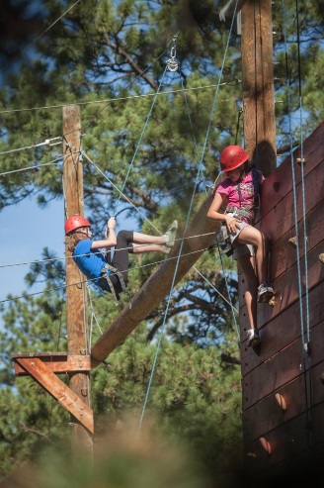

**Communication**

Our summer services are now integrated with the same system we use for camper registration. You can view/purchase photos, purchase camper email notes, read camp news, and set up user accounts for family members all through your online parent portal. Simply log into your family account and scroll down to the Online Community section.

**Photos –** Each evening we commit to post photos of the current days camp activities. These photos can be viewed by yourself and approved family members. They can also be purchased and printed. Occasionally we do have technical difficulties; if photos are not posted by midnight, please check for them the following morning.

**Blog –** We post regular blog posts written by staff members and campers throughout the session to tell the story of camp and give you the flavor of life at camp for your camper. You can view this blog on our website at [www.ranchamp.org](http://www.ranchamp.org) or through the News section of summer services account.

**Facebook-** Each day we will be posting information, updates and photos to Facebook. This is also a great way to stay connected to the Ranch Camp community year round. (Please keep in mind that we refrain from posting photos of individual campers while they are at Ranch Camp) Please join our community by “Liking” the JCC Ranch Camp page.

**Telephone-** The number of the JCC Ranch Camp's summer office is (303) 648-3800. We encourage your calls, and are happy to answer any questions. We will not put your child on the phone, unless, of course, it is an emergency.

**From the Counselors**

You will receive communication from your child's counselors while your child is at camp. Madrichim will send out two emails to their campers' parents during each camp session with updates on the bunk. First-time camper families will be contacted during the first 24-48 hours of camp by our Rosh Banim/Banot (unit heads) in order to give parents/ guardians an update on how their camper is adjusting to camp.

Please regularly check both your email and our Facebook pages for camp pictures, updates, etc. Ranch Camp makes every effort to keep parents informed of the daily activities of our camp with emails that are sent out regularly. Please make sure we have your correct email address.

**Letters from Your Camper**

Please send your camper with self-addressed envelopes, stamps and stationary to enable them to write home while they are at camp. We encourage campers to write letters home and give them time to do so. If you have concerns about any content in your campers’ letters home, please contact us at the Ranch Camp Office so that we can look into further and address potential issues.

**Communicating with Your Camper**

**Mail**

Campers Need Mail! A regular flow of mail to and from home can help promote your child’s positive feelings about camp and about being away from home. Packing self-addressed envelopes, stationary and stamps will help facilitate the flow mail from campers to home. The Ranch Camp delivers all outgoing mail to the Elbert Post office daily (except Sundays) by 1 p.m. and all incoming mail is delivered to campers daily after lunch (except for Saturdays).

**Please send mail to:**

Child’s Name

c/o JCC Ranch Camp

21441 N Elbert Rd

Elbert CO 80106

**Packages**

You may send non-food items such as magazines, games, cards, etc. "Sealed with a Kiss" and "Wrinkled Egg" are two companies that you can use with options for ready- made packages for your child. **Please limit the total number of packages you and families send to one or two per session and instead focus on letters.**

**DO NOT SEND FOOD IN CARE PACKAGES!**

All food campers bring to camp will be confiscated on the first day. We feed them healthy, nutritious, kosher food and snacks, so your child should be able to find many foods he/she enjoys. Food in bunks attracts mice, rats, raccoons, and skunks to the cabins and interferes with our kashrut supervision. All campers will open packages under staff supervision. It is tempting to send food, but please don't. This policy also includes packing food for your camper in his/her trunk. We need your cooperation! Nothing makes a camper as sad as having his/her food taken away.

**Email**

Through your Ranch Camp account you are able to send your camper email or bunknotes. To take advantage of this service, you will need to purchase our online currency called Camp Stamps. This can be done by logging into your family account and clicking the option for “Camp Stamps”. After you purchase Camp Stamps, you can then use them to purchase emails. There is no limit on who many emails you send your child each day, though we ask you to keep in mind the environmental impact of printing emails and request that you put as much information into one email as possible! You can also invite family members to send emails by creating a guest account, which can also be done on your account. Emails will be printed each day before lunch and placed in cabin mailboxes.

**Mail for Campers on Trip Programs**

If your child(ren) are participating in 8th Grade Ranch, TASC, Teen Village, Rock 'n Ride, or Pack 'n Ride, please note that mail is collected at camp for campers while they are away on their tripping programs and then is distributed to them upon their return to camp. We will make an effort to deliver mail to Teen Village campers once during their trip experience.

**We welcome any questions or concerns you may have during the camp season. You can email us at** [**ranchcamp@jccdenver.org**](mailto:ranchcamp@jccdenver.org)**.**



**Additional Information While at Camp**

**Bar/Bat Mitvah Support**

We can provide Bar and Bat Mitvah support at camp. A trained staff member will meet with campers twice during their session, reviewing any study material that they have brought with them to camp and making sure that they stay on-track in their studies while at camp.

**Birthdays**

At the Ranch Camp, each birthday is a special day. We have our own way of celebrating within our camp community. We encourage parents to send packages with decorations and/or party favors for the cabin to help celebrate. We ask that while you help your child celebrate, you keep in mind that he/she is at camp with 6-12 other bunkmates. Anything you may wish to do should be inclusive to the cabin community.

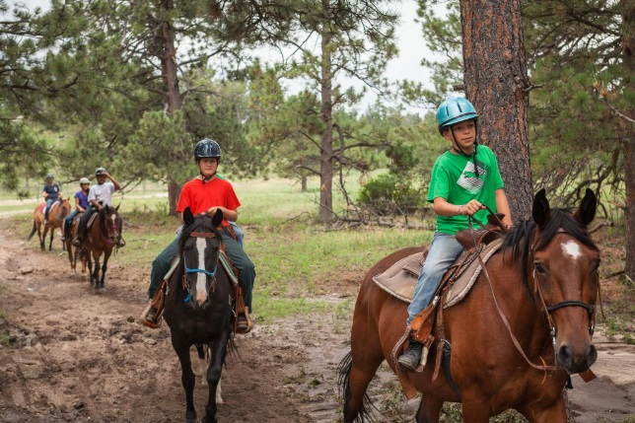

**Bunkmate Requests**

We will do our very best to accommodate everyone. However, due to various cabin sizes, the Ranch Camp cannot guarantee bunking requests. We try to honor old friendships, encourage new ones, and create a community in which all can be happy. If you have a particular concern, please email us or call our office.

**Kashrut**

The JCC Ranch Camp is a kosher facility. We maintain a supervised kosher kitchen (not Vaad supervised), and monitor all foods campers eat while at camp. Depending on the season, we either have a mashgiach on-site or our mashgiach visits our site a few times a week to ensure standards are met.

**Laundry**

Campers’ laundry will be done once during Sessions 1, 2, and 3. **No laundry will be done during Mini Sessions, TASC, Rock n’ Ride, Pack n’ Ride and Teen Village.** All laundry is done on the premises by a trained staff member.

**Lost & Found**

Lost & Found is displayed at camp throughout each session and before campers leave each session. The #1 way to ensure lost items are returned is to label your clothing with both you campers’ first and last name. After the end of the session, unclaimed Lost & Found items will be brought to the Denver JCC. All items not claimed by the end of August will be donated to a community organization.

**Ranch Camp Clothing**

Your camper will receive one complimentary short-sleeved Camp T-shirt.

**Religious Services**

Services are held at camp in observance of Shabbat (Friday night, Saturday morning, and Havdallah on Sunday evening). They are run by staff and campers and are inclusive. The JCC Ranch Camp is committed to being a home for all Jews, and for those who are willing to respect and support the Jewish faith and people. Ranch Camp provides an environment where campers and staff can observe Shabbat according to their own traditions but we are not Shomer Shabbat as a community.

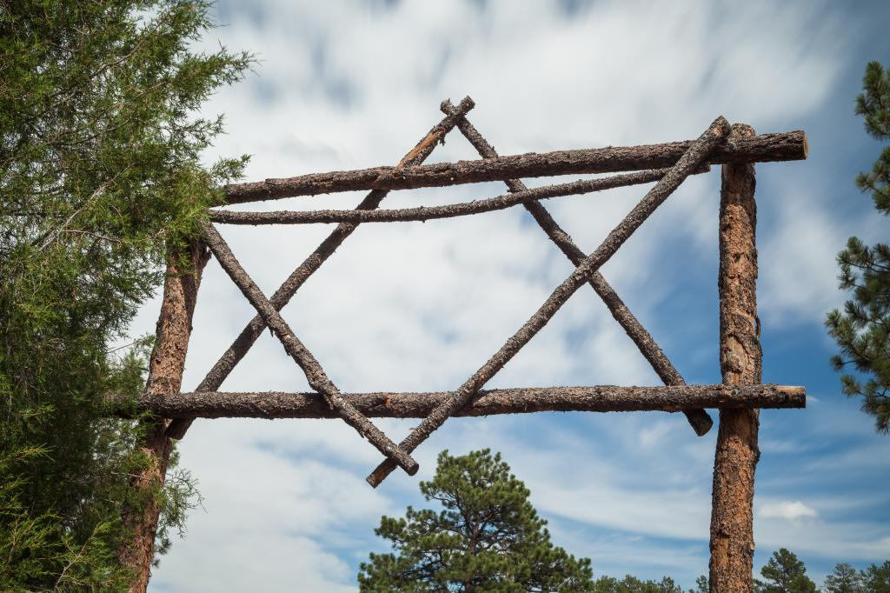

**Security**

The JCC Ranch Camp is a secluded environment with singular access that is gated. We are ever vigilant for any unsafe situations. Children are supervised at appropriate levels while in and out of the cabin.

**Tipping**

Jewish ethics teaches that “a mitzvah is its own reward” (Pirkei Avot 4:7). In keeping with our heritage and the guidelines of the American Camping Association (ACA), gratuities are not accepted by our staff. A short note or verbal thank you is the best form of appreciation or, if you would like, you may make a donation in someone’s honor to our Staff Appreciation Fund or to our Camper Scholarship Fund. Please be sure to notify the directors about exceptional staff members.

**Valuables**

Camp provides all meals and snacks when campers are on-site and leave our facilities for road trips, so giving your child money to bring to camp is totally unnecessary. Campers traveling by airplane who have money to buy things at the airport or who are carrying electronics will give it to their counselor, who will then deliver it to the directors’ office for safe holding until they leave camp. Please see list of things not to bring to camp.

The Ranch Camp is not responsible for lost or damaged personal property. NO CELL PHONES OR ELECTRONICS ARE PERMITTED AT CAMP. The only exception to this rule are ipods or personal music devices used by campers studying for their b’nai mitzvah during camp, which are allowed to be kept with the camper. Any other electronic items will be held for safe keeping if found or handed over, and delivered back to campers at the end of the session. Please make sure that all items are clearly labeled with the camper’s first and last name.

**Licensure Abuse Statement**

In the event of suspicion of child abuse or neglect of any enrolled children, staff members are required to report this to the director. The director or staff member will, in turn, report the findings to Child Protective Services.

As a parent of a child in a licensed childcare center, you may report any suspected abuse by calling the Child Abuse Hotline at 720-944-3000.  If you wish to make a complaint or have a concern regarding your provider you may call the Public Health Inspection Division at 303-285-4075 or the Colorado Department of Human Services at 303-866-5958.

**Activity Offerings**

We do our best to get campers around to all our activity offerings multiple times during the course of their session. While most of our activities are open to all age groups, some of the activities are limited to older campers because of the equipment being used and/or the physical intensity of the activity. We are a “challenge by choice” program, which means that while we encourage campers to try all the activities, they are not pushed to participate in activities that they do not want to do.

Inclement weather during the session can require that some activity periods are cancelled. We will reschedule cabin groups for certain activities such as horseback riding, archery, pool, and ropes course, if time and schedule allow.

**Please note that Mini Campers are scheduled at least once for all activities that they are eligible to participate in. Mini Camp is a “taste of camp” experience and the short time frame does not often allow for campers to get to do many of the activities more than once.**

Activities with age limitations: Mountain Biking - 6th graders and up

We attempt to schedule all Ranch Program campers twice for each activity during their

session, and three times at the corral during their session.

**.**

**.**

**.**

**.**

**.**

**.**

**.**

**.**

**.**

**.**

**.**

**.**

**.**

**.**

**.**

**.**

**.**

**.**

**.**

**.**

**.**

**.**

**.**

**.**

**.**

**.**

**.**

**.**

**.**

**.**

**.**

**.**

**.**

**.**

**.**

**.**

**.**

**.**

**.**

**.**

**.**

**.**

**Sample Daily Schedule**

**Morning**

7:45 Degel (Flagpole)

8:00 - 8:45 Breakfast

8:45 - 9:15 Cabin Clean-up

9:20 - 10:35 Cabin Activity #1

10:40 Snack

10:45 - 12:00 Cabin Activity #2

12:15 - 1:15 Chug 1: Daily Free Choice Activity

**Afternoon**

1:15 – 2:00 Lunch

2:00 - 2:45 Menucha (Rest Period)

3:00 - 4:15 Cabin Activity #3

4:20 - Snack

4:30 - 5:30 Chug 2: Weekly Elective Activity

5:30 - 6:00 Cabin Time

**Evening**

6:00 Degel (Flagpole)

6:10 - 7:00 Dinner

7:15 - 9:00 Evening Activity

9:15 Lila Tov (Good night)

**PACKING FOR CAMP**

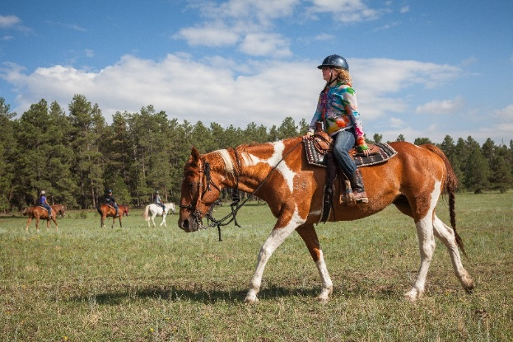

**Label Clothing and Equipment**

Please be sure that each item is clearly marked with the camper’s FIRST INITIAL AND FULL LAST NAME (even on socks and underwear!). Initials are not sufficient to enable us to return items to campers. The best luggage is a large, top-open duffel bag or a trunk. Linens can be packed in your camper’s laundry bag or another duffel bag. The idea is to have items easily accessible. There will be some shelf space provided for each camper, but it may not be sufficient to store everything that they’ve brought. Please make sure to let your camper help pack so they feel comfortable knowing what they have and where everything is located. Duplicating this clothing list and taping/attaching it to the inside of a trunk or duffel bag often facilitates easier packing at the end of each session.

**water bottles +**

**sunscreen +**

**brimmed hat +**

**closed-toe shoes =**

**ONE HAPPY CAMPER!**

**A few words on what to bring:**

There are a few items on the list that we would like to stress as CRITICAL for your child to have a safe and enjoyable summer:

• Your camper MUST carry a water bottle or canteen at all times. The campers are busy all day and need plenty of fluids on a regular basis to prevent dehydration.

• Sunscreen and a brimmed hat are essential to prevent burning. Most activities are outside in the sun, and your child needs to be properly protected.

• The American Camping Association requires a smooth, hard-soled shoe (i.e. no hiking boots) with a heel that comes above the ankle for horseback riding. Ranch Camp has extra pairs of boots that campers can borrow. If you want to buy boots, thrift stores and Walmart/Target often have inexpensive cowboy boots. Sheplers (in Colorado) also often runs sales where boots can be purchased for $10 to $15.

**A few words on what NOT to bring:**

As well as those items that are essential for a positive camping experience, there are items that can cause environmental or behavioral problems at camp, and those that we are simply not licensed to allow. Please read this list carefully and ensure that NONE of these items make it into your child’s luggage. We really need your help on this issue to make certain that the camp has a fun, safe, and clean environment.

• Food!

• Money, other than for plane travel.

• Cell phones, electronic games, e-readers, and iPods are not allowed at camp (exception: personal music devices used for Bar/Bat Mitzvah training). The Ranch Camp provides programming with many outdoor and creative activities to expose your child to new experiences. Electronics should be left at home.

• Shaving cream should not be brought to camp unless your child actually uses shaving cream at home.

• Silly string has no constructive purpose, damages buildings, is not readily biodegradable, and is often consumed by our furry friends (which results in illness and/or death).

• Knives or any other weapons of any shape or size are not needed for any camp programs, and they are therefore prohibited.

• Roller blades and skateboards require special licensing and staff training that goes beyond the scope of programming offered at the Ranch Camp. We therefore cannot allow campers to use these items and must ask that they are left at home.

• Camp is a place to be comfortable, but some clothing is not acceptable. Please leave bare midriff tops, short shorts, and sheer or revealing clothing at home; clothing with alcohol, drug-related, sexual, or degrading images and/messages are not allowed at camp!

.

.

**Next Section: Packing Lists**

**General >**

**Trip Camps >**

**EQ Camp>**

**Rock n’ Ride >**

**.**

**.**

**GENERAL PACKING LIST**

NOTE: EQ and Trips campers need to refer to additional packing lists.

**This packing list is designed for campers who will be attending a 19-day Ranch Camp session. Session 1 and Mini campers can bring reduced amounts of clothing items. Please call the office if you have any questions about what or how much to pack.**

Note: The temperature at camp allows for shorts and t-shirts during the day (75-90 degrees), but somewhat warmer clothing is needed for the evening (55-70 degrees).

**Clothing**

__1 pair of tennis shoes or hiking boots

__1 pair of riding boots (optional, the corral has boots that campers can borrow.)

__1 pair of sandals

__2 pairs of warm pajamas

__1 bathrobe (optional)

__1 raincoat or poncho

__12 pairs of socks

__12 pairs of underpants

__10 T-shirts

__1-2 Shabbat outfits*

__5 pairs of jeans or long pants

__5 pairs of shorts

__1-2 bathing suits

__2 sweatshirts/flannel shirts/sweaters

__1 pair of sweatpants

__1 warm jacket (A lightweight but wind and water resistant jacket with a hood is best.)

__1 brimmed hat (Very important item)

__1 belt

*Shabbat outfits should be slightly nicer but still camp appropriate clothing. Sundresses, skirts and scandals are popular, as are slacks with colored shirts. White is a traditional and popular color to wear on Shabbat.

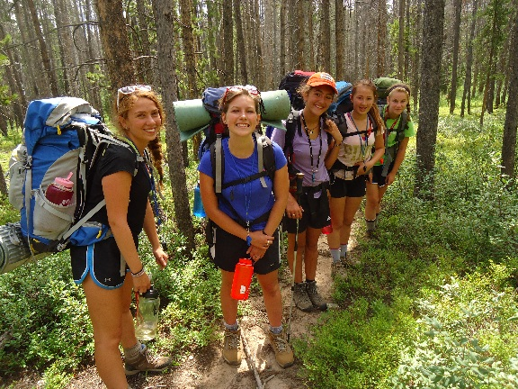

**Linens**

REQUIRED by state law. All children must bring the linens listed. Campers may not sleep in his or her sleeping bag except for campouts.

__2 sets of bed sheets

__2 pillowcases

__1 blanket or lightweight comforter

__1 bath towel

__1 wash cloths/hand towel

__1 pool towel

__1 laundry bag

__1 pillow

*If you are traveling from out-of-state and would like to rent Ranch Camp linens, please contact the office.

**.**

**Camping Gear**

__sleeping bag (must be compact and lightweight to carry to campsites)

__sleeping pad (optional)

__flashlight

__day-pack to carry items to campouts

**Toiletries, etc.**

__2 canteens/water bottles (make sure they are labeled!)

__sunscreen

__mosquito repellent

__bucket or bag to carry toiletries to the washhouse

__shampoo/conditioner

__toothbrush and container

__toothpaste

__hairbrush/comb

__soap/soap box

__body lotion

__lip balm

__nail clippers

__tissue

__stationery/pens/postcards (Pre-addressed cards for younger campers are great!)

__stamps

__It is highly recommended that all campers bring a small bottle of nasal saline spray. Due to the severe dryness at camp, most campers end up with stuffed noses, making it hard to sleep at night. This is basically salt water with preservatives that each camper can spray in their nostrils, and then blow their noses. It’s a small item that will make nights more restful, and days more fun. You may also send “Ayr” nasal gel, a water-based moisturizer. Campers can keep both these items in their cabins or take them on trips. Please write names on bottle in marker-these items must not be shared!

**Optional**

__camera (disposable cameras are ideal for children. These cameras produce nice quality pictures with ease and are inexpensive. Digital cameras not recommended for camp.)

__hip pack to carry inhalers or bee sting kits, etc.

__books/magazines

__baseball glove

__musical instruments (Within reason—call if you have questions.)

__cards/jacks

__costumes (For skits in the talent show!)

__stuffed animals

__long underwear

__Kippot/Tallit

__ Red, yellow, blue, and green clothing for Maccabiah (an all-camp color competition).

__ White t-shirt, or other white clothing items to tie-dye.

**.**

**ADDITIONAL PACKING LIST FOR CAMPERS ENROLLED IN TRIP PROGRAMS**

(8th Grade Ranch, TASC, and Teen Village)

**Note to Parents:** Please read through the following list very carefully. It has been put together after many years of successful

wilderness trips. Your child’s enjoyment and safety during the trip start with them bringing the appropriate gear and clothing.

* **Backpack** – The only requirement is that the backpack has a frame (either internal or external), a well-padded hip-belt (50-60% of the pack’s load should be carried on the hips), and a capacity of around 3000 cubic inches. The fit of the pack is the most essential factor and can make a backpacking trip either pleasant or painful. We cannot emphasize enough the importance of a well-fitted backpack! The camper will suffer if the backpack does not fit properly. Most outdoors stores (like REI) will help you pick the correct pack and/or customize a pack to properly fit.
* **Sleeping Bag** – NO DOWN! A good night of sleep is essential for performance in the outdoors. Warmth is the main factor, but performance under wet conditions is not the same for all bags. Down bags are very compact (and pricey) and warm, but are of no use at all when wet. Bags using synthetic fill are bulkier but retain warmth when wet and require less care than down. A temperature rating of 20 degrees Fahrenheit will be adequate for most people in the alpine area, which has highly varied and unpredictable temperatures in the summer. Avoid bulky sleeping bags as they can affect the fit of the backpack. Absolutely no cotton!
* **Sleeping Pad** – This is more for insulation than comfort. The body loses heat to the ground through conduction, and a backpacking air mattress (ThermaRest, Insulex) or closed-cell foam pad (Ensolite, Ridge Rest) slows the heat loss appreciably.
* **Footgear** – Shoes should be, above all else, comfortable and well broken in. Ankle support and traction are two other essential features. There are a wide variety of boots on the market, ranging from high tech to traditional, but there is no need for anything fancy. Shoes must come over the ankle for support when carrying a backpack. It is also advised to bring along a second pair of tennis shoes or sandals that fasten to the foot (Chacos or Teva, NO flip-flops) to be worn around camp. Socks (3-4 pairs) need to be wool or wool synthetic blend, for warmth and cushioning. Polypro liner socks can help prevent blisters.
* **Clothing is just as important as gear**. The unpredictable climate can place you alternately in weather that is ninety degrees and sunny, and an hour later in a gale force storm with temperatures in the 50’s and rainy. The following clothing items are essential for the areas in which your child will be visiting:
* **Hat** – Wool or pile camp that covers the ears. 70% of the body’s heat loss occurs through the head. The old adage, “If your feet are cold, put on a hat,” holds true to this day.
* **Sweater** – Again, wool or fleece are the preferred materials due to their ability to retain heat when wet. Sweatshirts are designed to exercise in, to keep the body cool, i.e. to lose heat. Their insulating value is low, (i.e. they lose heat so they cannot be used in place of a sweater). Two sweaters/fleeces are required for the trip, one as a backup layer for inclement weather.
* **Long johns** – These are the foundation of the layering system for almost any wilderness activity. They are warm when wet, dry quickly, are light and compact, and grant some relief from monster mosquitoes in the summer. Capilene and polypropolene are two materials on the market. At least two tops and one bottom for each camper.
* **Raingear** – Water washes away heat quickly, and the difference between health and hypothermia can be as easy as an adequate rain jacket. The rectangular ponchos seen at sporting events are poor when hiking or when wind is present. A rain jacket with a hood is a must to protect the body core from heat loss, it should be waterproof and breathable. Rain pants are a must as well.
* **Pants** – Quick drying, non-cotton is best. 1 pair
* **Shorts** – Quick drying, non-cotton are best. 2-3 pair (one less if they are long pants with zip off legs that convert to shorts).

**Other Essentials** – Some of these items are mentioned on the regular packing list, others are not. We included items that we wanted to emphasize on both lists:

• 2 one liter water bottles (Nalgene or Sigg) • Sunglasses • Sunscreen • Ball cap (or hat with a visor) • Wool gloves or mittens • Mosquito repellent • LED flashlight (or Head lamp is preferred) with extra batteries • Light weight mess kit (including a cup, plate, bowl, and silverware) • Whistle on a cord (to be worn around the neck) • An extra pair of glasses or contacts • Extra inhaler or bee sting kit.

**Leave at Camp:** Jeans, Cotton sweatshirts, flip flops, broad brimmed sun hats, pajamas, bathrobes, and dressy Shabbat cloths.

**Tips for shopping:** While stores like REI have the advantage of trying things on and the help of a sales person, parents can also check out the following websites for less expensive alternatives:

[www.sierratradingpost.com](http://www.sierratradingpost.com)

[www.libertymountain.com](http://www.libertymountain.com)

[www.craigslist.org/about/sites](http://www.craigslist.org/about/sites)

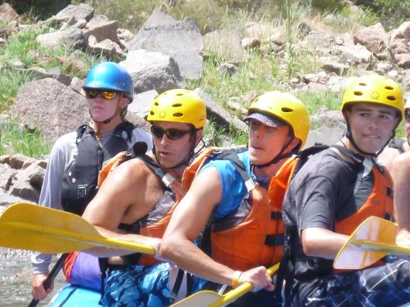

**Next:**

**EQ Camp >**

**.**

**.**

**.**

**.**

**.**

**.**

**.**

**.**

**.**

**.**

**.**

**Additional Packing List for EQ Campers**

**Riding Helmet** – Must meet ASTM standards and be SEI approved. Helmets must be worn by campers at all times when in the corral. JCC Ranch Camp provides riding helmets for campers, but EQ campers often elect to bring their own helmets to camp. Make sure that your camper’s helmet is comfortable and has vents to help them stay cool. Velvet show helmets are NOT recommended.

**Extra Jeans** – EQ campers are required to wear jeans to ride in daily. You need not pack your camper with as many shorts as recommended on the General Packing List, but it is suggested that you bring 5 pairs of jeans for riding, in addition to a few pairs of pants for the evenings and weekends.

**Riding Boots** – Western riding boots with a smooth sole and heel are required for riding. Make sure to wear-in new boots before arriving to camp to avoid a painful break-in process and blisters. While Ranch Camp has extra pairs of boots to lend Ranch Program campers, EQ campers are required to bring their own personal pair of riding boots to camp. Hiking boots are not riding boots. See page 18 for boot buying suggestions.

**T-Shirts** – Please note that campers are required to wear shirts WITH sleeves in the corral. No tank-tips/singlets are permitted to be worn while riding; this rule is important for horse safety, as well as sun safety. Make sure to pack your campers t-shirts, long-sleeved shirts, and sweatshirts that you and your camper do not mind getting dirty!

**Hat** – Be sure to bring a baseball cap or cowboy hat to wear when not riding or instructing. It is easy to get sun-burned and dehydrated during the summer months at our elevation.

**Other Essentials** –(Some of these items are mentioned on the regular packing list, others are not. We included items that we wanted to emphasize on both lists.) 2 water bottles, sunglasses, sunscreen, mosquito repellent, an extra pair of glasses or contacts, and an extra inhaler or bee sting kit.

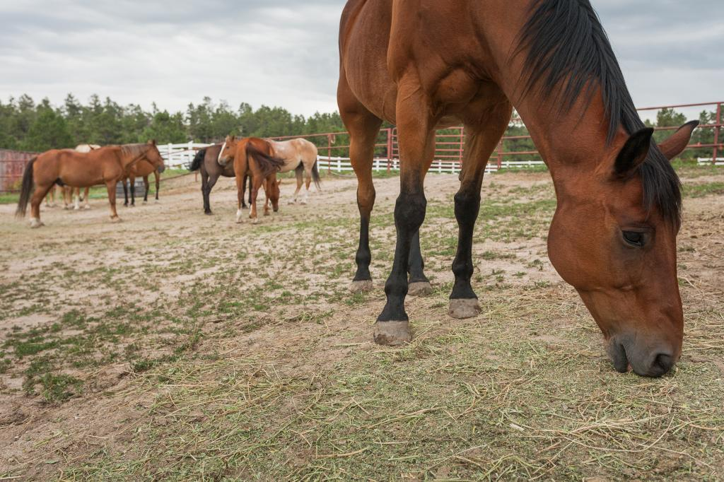

**Next:**

**Pack n’ Ride >**

**Additional Packing List for Pack n’ Ride Campers**

**Clothing and Riding Gear**

__3 pairs of riding jeans

__Swimsuit for the Hot Springs!

__Riding Helmet (optional ). Camp will provide but you are welcome to bring your own

__Riding Boots

__At least 5 pairs of tall socks appropriate for wearing under boots

__1 or more pairs of warm socks for cold nights (merino wool recommended)

__Long underwear (top and pants) - we recommend synthetic or merino wool

__Clothes for in-camp activities, see general packing list. For example:

__Shorts

__Tennis shoes

__Flip flops for showering

**Camping Gear**

__Raincoat - Gortex or like fabric is highly recommended

__Stuffable/compactable sleeping bag-synthetic or down but needs to be rated to 15 degrees Fahrenheit or less

__Sleeping Pad - also must be able to deflate or compress

__Another pair of waterproof boots, either good hiking boots or just cheaper rubber boots. They will be used early in the morning and after the ride in the evening when the area is wet.

__Neck warmer

*\*\*Rain pants will NOT be allowed when riding or working with horses\*\**

**Toiletries, etc.**

__Compact toiletries

__Hats (including warm hat for cold nights)

__Sunglasses

__Soft gloves (2 pairs). One can be leather and one can be wool. These will be used both during the actual ride and at night when it is colder.

__At least 3 Nalgene/1 liter water bottles

__Camelback-type water pack if desired

**\*\*Feel free to pack in any duffel bag as we will be repacking into the equipment provided by the outfitter!\*\***

**Next:**

**Rock n’Ride >**

**.**

**ADDITIONAL PACKING LIST FOR ROCK N’ RIDE CAMPERS**

**Bike Helmet** – needs to be in good working order and preferably less than 3 years old. Mountain bike style helmet rather than BMX or Skate style helmet.

**Padded Bike Shorts** – not essential, but makes long days of riding more comfortable.

**Padded Bike Gloves** – to protect hands if the camper should come off bike.

**Jersey Shirts** - no cotton tees for riding. Needs to be quick-drying and breathable.

**Hydration Pack** - (i.e. Camelback or equivalent) min 2 liters, with a storage pocket.

**Mountain Bike (optional)** - Must be safe and in good working order. Should have at least one water bottle cage with water bottle. Min 21 speed bike.

**Long johns** – These are the foundation of the layering system for almost any wilderness activity. They are warm when wet, dry quickly, are light and compact, and grant some relief from monster mosquitoes in the summer. Capilene and polypropolene are two materials on the market. At least two tops and one bottom for each camper.

**Raingear** – Lightweight riding jacket, something not too bulky that camper can ride in. Water washes away heat quickly, and the difference between health and hypothermia can be as easy as an adequate rain jacket. The rectangular ponchos seen at sporting events are poor when hiking or when wind is present. A rain jacket with a hood is a must to protect the body core from heat loss, it should be waterproof and breathable.

**Hat** – Wool or pile camp that covers the ears. 70% of the body’s heat loss occurs through the head. The old adage, “If your feet are cold, put on a hat,” holds true to this day.

**Sweater** – Again, wool or fleece are the preferred materials due to their ability to retain heat when wet. Sweatshirts are designed to exercise in, to keep the body cool, i.e. to lose heat. Their insulating value is low, (i.e. they lose heat so they cannot be used in place of a sweater). Two sweaters/fleeces are required for the trip, one as a backup layer for inclement weather.

**Sleeping Bag** – NO DOWN! A good night of sleep is essential for performance in the outdoors. Warmth is the main factor, but performance under wet conditions is not the same for all bags. Down bags are very compact (and pricey) and warm, but are of no use at all when wet. Bags using synthetic fill are bulkier but retain warmth when wet and require less care than down. A temperature rating of 20 degrees Fahrenheit will be adequate for most people in the alpine area, which has highly varied and unpredictable temperatures in the summer. Avoid bulky sleeping bags as they can affect the fit of the backpack. Absolutely no cotton!

**Sleeping Pad** – This is more for insulation than comfort. The body loses heat to the ground through conduction, and a backpacking air mattress (ThermaRest, Insulex) or closed-cell foam pad (Ensolite, Ridge Rest) slows the heat loss appreciably.

**Other Essentials** –(Some of these items are mentioned on the regular packing list, others are not. We included items that we wanted to emphasize on both lists.) 2 water bottles, sunglasses, sunscreen, mosquito repellent, an extra pair of glasses or contacts, and an extra inhaler or bee sting kit.

**Next:**

**Trip Camps >**